FMX Mobile Application Development

**Lab Exercise 02.05 : Running an InterBase Script**

You can execute sql scripts in the Interactive SQL window of the IBConsole. To create, open or modify data definition files, you can use a text editor such as Notepad++.

### **CONNECT Statement**

Every SQL script must begin with a **CONNECT** statement. The **CONNECT** statement specifies a complete path to the database, a user name, and a password. However, if you connect to a database beforehand, you may omit the **CONNECT** statement when executing an SQL script in the Interactive SQL window.

If you do specify a connect statement, make sure to modify the values accordingly. The SQL scripts that accompany this tutorial begin with the following **CONNECT** statement:

**CONNECT** 'C:\Data\EMBEDDEDIBLITE.IB'  
**USER** 'SYSDBA' PASSWORD 'masterkey'  
**NOTE:** Before executing a script with the above **CONNECT** statement, check your paths and connection statement

Run the EmbeddedIBLite.SQL Script

1. Download the EmbeddedIBLite file to your computer.
2. Load the **EmbeddedIBLite.SQL** script.
3. Execute the query.
4. To confirm that the tables now exist, click on **Tables** item in the left pane of IBConsole.

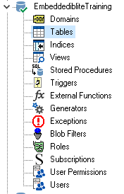

You should see the following tables:

